Factors of delayed seeking of medical care and treatment of ca breast patient
Background
In our country, usually ca breast diagnoses at advanced stage, this adversely affect the prognosis. Causes of delayed presentation to the medical facility is multifactorial. This study will be carried out to determine the factors of delayed seeking of medical care and treatment of the ca breast patients.
Methodology
This will be a cross sectional study, will be carried out in Department of Radiotherapy of Rangpur Medical College Hospital. Assuming unknown prevalence of ca breast in this region a sample size of 384 will be calculated to give the true prevalence with a precision of 5% with 95% of confidence level. On an average about 30 patients visits to Department of Radiotherapy. Purposive sampling technique will be used to collect the sample, from the daily visited patients, newly diagnosed ca breast patients will be included in our study.
Expected outcomes
From this study we will be able to reveal the factors of delayed seeking of medical care and treatment of ca breast patient.
Utilization
The factors of delayed seeking of medical care and treatment will be used to aware the people, so that early diagnosis and treatment will be possible in future.

Objectives
General objective
- To determine the factors of delayed seeking medical care and treatment of ca breast patient.
Specific objectives
- To determine the factors of delayed seeking medical care of ca breast patient.
- To determine the factors of delayed diagnosis of ca breast patient after presenting to medical care.
- To determine the factors of delayed starting of treatment of ca breast patient.
- To see the frequency of staging of ca breast at the time of diagnosis.

 | Delayed Treatment (Yes) | Delayed Treatment (No) | Total
Delayed Diagnosis (Yes) | 11 | 10 | 21
Delayed Diagnosis (No) | 19 | 166 | 185
Total | 30 | 176 | 206

Chi-square Test Results:
• Chi-square statistic (Pearson chi2): 26.8787
• P-value (Pr): 0.000

Interpretation:
1. Chi-square statistic: The chi-square value of 26.8787 measures the degree of association between delay in diagnosis and delay in treatment. The higher this value, the more evidence there is to suggest a relationship between the two variables.
2. P-value: The p-value of 0.000 is less than the commonly used significance level of 0.05. This indicates that there is a statistically significant relationship between delay in diagnosis and delay in starting treatment.

Conclusion:

There is strong evidence to suggest that delay in diagnosis is associated with a delay in starting treatment for breast cancer. Specifically:
• 11 individuals who had a delayed diagnosis also had a delayed start of treatment.
• 19 individuals who did not have a delayed diagnosis experienced a delay in treatment.

Since the p-value is less than 0.05, we can confidently reject the null hypothesis (which assumes no association) and conclude that the delays in diagnosis and treatment are significantly correlated.
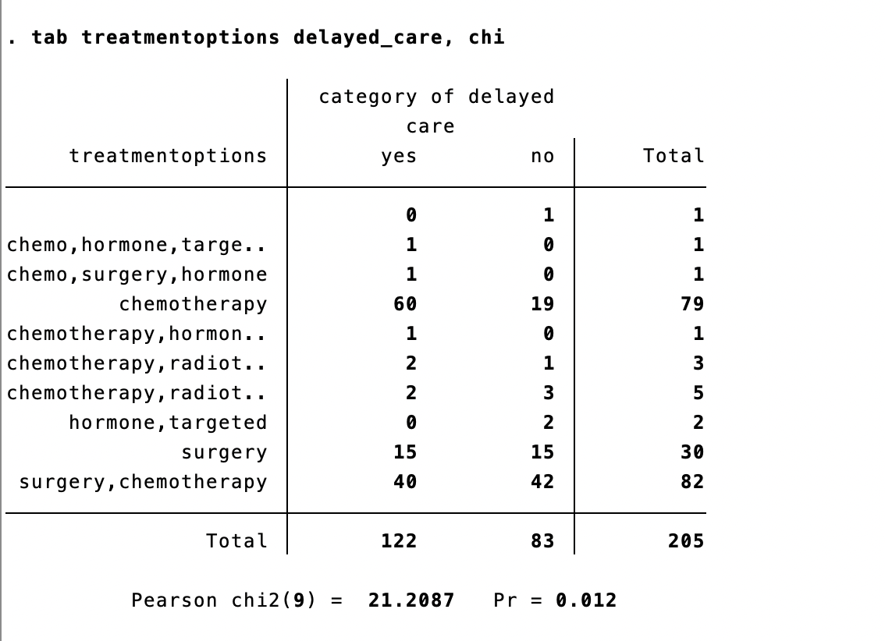
Interpretation:
- Chi-square statistic: The Pearson chi-square value of 21.2087 measures the strength of the association between treatment options and delayed care. A higher chi-square value indicates a stronger association between the two variables.
- P-value: The p-value of 0.012 is less than 0.05, which means that the association between treatment options and delayed care is statistically significant.

Conclusion:

Since the p-value is less than the standard threshold of 0.05, we can reject the null hypothesis, which states that there is no association between the treatment options and the delayed care variable. This means that treatment options have a statistically significant effect on whether care is delayed or not.

Key Findings:
- Chemotherapy treatment has the highest number of delayed care cases (60 out of 79), indicating that chemotherapy might face logistical or access-related delays.
- Surgery combined with chemotherapy also shows a substantial number of delayed care cases (40 out of 82), suggesting that combining treatments may contribute to longer wait times.
- Hormone and targeted therapies appear to be associated with fewer delays, as they have no or minimal delayed care.

This association shows that more complex treatment regimens like chemotherapy and combination treatments are likely to experience more delays in care compared to simpler options like surgery or hormone therapy.

